**LOOP DFS**

**Merchant Quick Loan**

**Technical Requirement Specification**

|  |  |
| --- | --- |
| **Version:** | 1.0 |
| **Release Date:** | 28th August, 2025 |
| **Prepared by:** | Manley Nyasinga |
| **Document Name:** | **Merchant Quick Loan**  **Technical Requirement Specification** |

**1. Overview**

**1.1 Purpose**

The purpose of this document is to define the technical requirements for the implementation and operation of the **Loop Merchant Quick Loan** product. The product implementation will be utilized by Sole unregistered merchants and sole registered merchants via the loop merchant app. The merchant quick loan will be a monthly loan (30-day loan).

**1.2 Scope**

The **Loop Merchant Quick Loan** product allows merchants to access short term loans from the merchant application with variable fees according to the loan tenor selected. This section breaks down the different technological elements that will allow the customers to utilize the product and allow the business to efficiently manage the loan product.

**Front-End Scope**

1. **Loan Draw Down**

* **FR-1.1** – **Quick loan Access:** The Merchant quick loan will be accessible in the Loop merchant app on the account page. The quick loan option will be created in the Account page according to the below design.

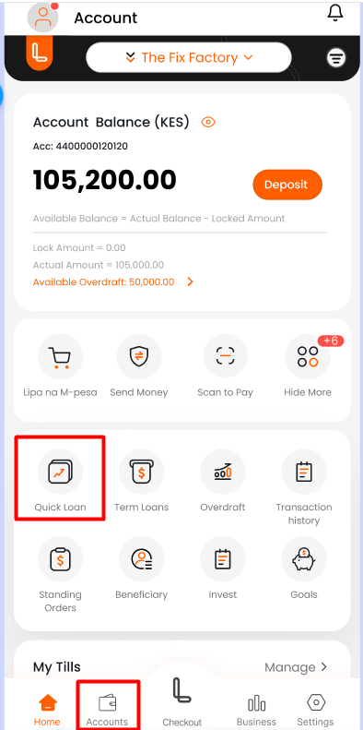

* **FR-1.2** – **Quick loan** **VUE Whitelist:** The quick loan option will be controlled by the in-built whitelist capability to only display for merchants who are whitelisted to access the product.
* **FR- 1.3** – **Quick loan Homepage:** The quick loan home page will display the loan limit allocated to the merchant as below.

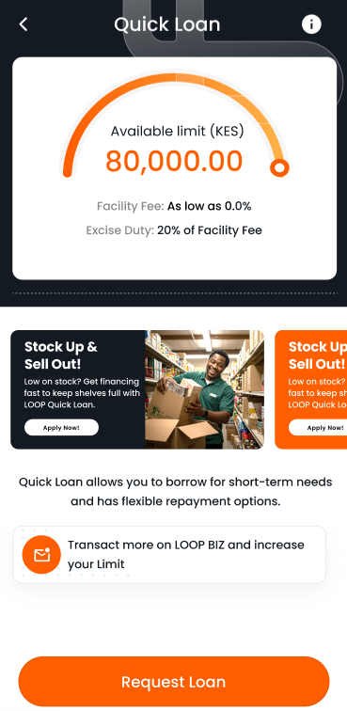

* **FR-1.4** – **Quick Loan Amount Validation:** The Loop merchant application front-end will allow the merchant to input the loan amount they need to borrow. The app will validate that the amount the merchant inputs does not exceed the loan limit allocated.

* **FR-1.5 – Quick Loan Tenor Validation:** The Loop merchant application front-end will query the loan fees charged for the merchant quick loan and populate the tenor segments returned with the fee response. The tenors will be cached on the front-end app while the customer is logged in in the same session.

* **FR- 1.6 – Quick loan Summary:** The Loop merchant application will display the loan summary that contains the principal loan amount, the fees to be charged for the amount borrowed and the repayment amount expected. The amounts will be displayed according to the tenor selected and the corresponding facility fee charged for the selected tenor
* **FR- 1.7 – Quick loan draw-down summary page:** Once the merchant is comfortable with the loan amount and the selected tenor they will select continue to proceed with the loan request. The merchant app will display the loan break-down summary as below.
* **FR- 1.8 – Quick loan terms & conditions:** The merchant application front-end will provide a section for the customer to review the terms & conditions associated with the merchant quick loan facility. The front-end application will keep the **‘Accept offer’** button deactivated until the customer checks the offer letter and terms and conditions options.

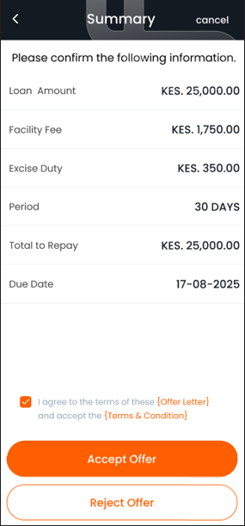

* **FR- 1.9 – Quick loan offer reference validation:** Once the customer accepts the loan offer the merchant application will provide an option for the customer to input the loan offer reference number. The offer reference number will be sent to the customer via SMS notification, push notification and email.

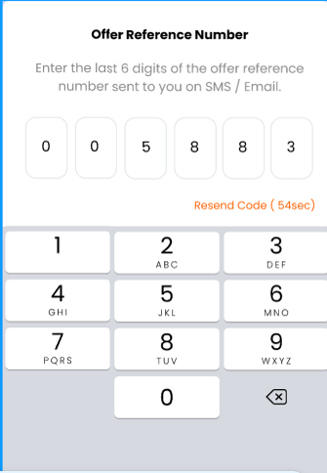

* **FR-2.0 – Quick loan PIN validation:** Oncethe offer letter reference is validated successfully the loop merchant app will prompt the customer to input their PIN for transaction validation.

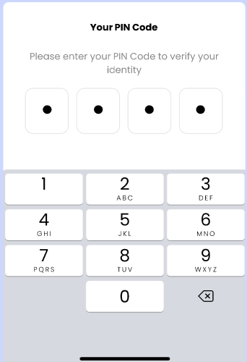

* **FR-2.1 – Quick loan success page:** Once the loan has been disbursed successfully the loop merchant app will display the success page.

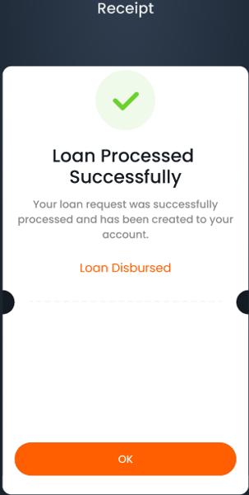

1. **Loan Top-up**

The merchant quick loan will allow the customer to request for a loan Top-up if they have not utilized their full loan limit and if the loan tenor has not exceeded the allowed period for a loan top-up which is proposed as 19 days.

1. **Loan repayment**

The Merchant quick loan will offer 2 main loan repayment methods to the customer as below.

1. **Automatic Loan Repayment**

This loan repayment method will trigger automatically on the loan due date where the Trinity End of Day process will trigger an auto sweep of the due loan amount from the merchant’s settlement account. If the merchant’s settlement account has insufficient funds the Trinity system will place a lock on the settlement account equivalent to the overdue loan amount.

1. **Manual Loan Repayment**

The Loop Merchant app will provide customers with an option to make early loan repayments from the front-end interface. The customer will see the **‘Repay loan’** option. The prepayment options offered will be partial repayment and full repayment.

**FR-2.2 – Partial Loan Repayment:** The loop merchant application will provide the customer with an option to make early repayment of the merchant quick loan.

**FR-2.3 – Full loan repayment:** The loop merchant app will provide the customer with an option to repay the full loan amount. Once the customer selects **‘Full loan Repayment’** option the app will fetch the loan balance and update this value in the amount field.

**Back-End Scope**

1. **Scene Application**

The Trinity system scene application service is a Multi-scenario Application that aggregates multi-module like consumer, merchant, savings, terminal equipment, money management.

**FR-1.9 – Product code update**: The scene application will be updated to include the new product code for Merchant quick loan (ELONGEN02).

**FR- 2.0 – Daily loan term period:** The daily term period will be updated support the different loan tenors offered by the merchant quick loan.

**FR- 2.1 – Merchant Quick loan Offer letter:** The merchant quick loan offer letter template will be updated to the scene application. The offer letter will

1. **Loan Product Configuration**

The merchant quick loan product will be configured on the BOSS portal with the determined business rules provided in the business requirement document.

1. **Loan Fees Configuration**

The Merchant Quick loan (30-day loan) will attract a facility fee that will be applied to the loan and charged according to the tenor that the merchant has selected. Below is the proposed facility fee charging.

|  |  |  |  |  |  |  |
| --- | --- | --- | --- | --- | --- | --- |
| **Tenure** | **Facility Fee** | **Rollover Fee** | **Penalty Fee Per Day** | **Tenure** | **Period after Rollover fee to apply penalty fee** | **Number of days to apply Penalty fee** |
| **1 day** | 0.00% | 2.50% | 0.20% | **1 day** | 5 | 24 |
| **5 days** | 2.50% | 2.50% | 0.20% | **5 days** | 5 | 20 |
| **10 days** | 4.00% | 4.00% | 0.20% | **10 days** | 10 | 10 |
| **20 days** | 5.00% | 5.00% | 0.20% | **20 days** | 20 | 20 |
| **30 days** | 6.00% | 6.00% | 0.20% | **30 days** | 30 | Nil |

* **FR-3.1 – Facility Fee Configuration:** The facility fee tiers will be configurable on the fee charge record. The differentiator will be the loan tenor selected with each tenor range attracting different facility fee rates.

|  |  |
| --- | --- |
| **Loan Tenor** | **Facility Fee Rate** |
| **1 day** | 0.00% |
| **5 days** | 2.50% |
| **10 days** | 4.00% |
| **20 days** | 5.00% |
| **30 days** | 6.00% |

* **FR-3.2 – Rollover Fee Configuration:** The merchant quick loan will attract a tiered rollover fee according to the documented business requirement. The rollover fee will be configured in the fee charge table with the below specifics. These rollover fee variables will be changeable at any point according to business needs. The number of Tiers can be changed at any point to increase the number of tiers or reduce the number of tiers.

|  |  |
| --- | --- |
| **Loan Tenor** | **Rollover Fee Rate** |
| **1 day** | 2.50% |
| **5 days** | 2.50% |
| **10 days** | 4.00% |
| **20 days** | 5.00% |
| **30 days** | 6.00% |

* **FR-3.3 – Daily penalty fee Charge:** The merchantquick loan will attract a daily penalty fee for a specified period that is configurable. The penalty fee will be applied after a specific number of days after the initial rollover fee is applied (penalty fee grace period).

**Penalty fee = Outstanding principle x daily penalty fee rate**

The daily penalty fee charge will be applied daily for a predetermined number of days as per the fee chart below.

|  |  |  |
| --- | --- | --- |
| **Loan Tenor** | **Daily penalty Charge days** | **Penalty Fee rate Per Day** |
| **1 day** | 24 | 0.20% |
| **5 days** | 20 | 0.20% |
| **10 days** | 10 | 0.20% |
| **20 days** | 20 | 0.20% |
| **30 days** | Nil | Nil |

* **FR-3.4 – Penalty Fee Grace period:** The merchant quick loan will have a tiered grace period from the rollover fee application date to the application of the penalty fee. The penalty fee grace periods should be configurable according to loan tenor or amount. The proposed tiers are as below.

|  |  |
| --- | --- |
| **Loan Tenor** | **Penalty fee application grace period (After rollover fee application)** |
| **1 day** | 5 |
| **5 days** | 5 |
| **10 days** | 10 |
| **20 days** | 20 |
| **30 days** | 30 |

1. **Loan Portfolio management process**

The portfolio management process will be configurable to manage the customer notifications and sanctions to be applied to the merchant quick loan according to the loan ageing. Below are the unique PMP actions to be configured.

* **FR-4.1 – Daily penalty fee application action:** The trinity system will provide an action to trigger daily rollover fee charges within the specified daily rollover period as per the loan tenor.
* **FR-4.2 – Tiered Rollover Fee:** The end of day process will incorporate a logic to validate the loan tenor against the rollover charge set for the specific loan tenor tier.

1. **Loan aging classification**

The loan aging classification manages the different stages of the loan life cycle.

**FR-5.1:** The merchant quick loan will have a unique loan classification configuration to manage the loan aging process. Each loan class will have specific GL accounts to manage the loan accounting entries for the different